**Top mentor – Mr Bose**

EXERCISE # - Regression

1. A plant manager wants to study the relationship between daily temperatures and plant output. What are the dependent and independent variables?

Dependent variable: Plant output

Independent variable: Daily temperatures

1. The general formula for linear regression is 𝑦̂ = 𝑏0 + 𝑏1𝑥 Describe each of the variables 𝑦̂, 𝑏0, 𝑏1, and 𝑥

̂ : Predicted or estimated value of the dependent variable

𝑏0: Y-intercept or constant term in the regression equation

𝑏1: Coefficient or slope of the independent variable 𝑥

𝑥: Independent variable or predictor variable

1. What determines that a line is the "best fit" for the given data?

Line minimizes the overall difference between the predicted values and the actual values of the dependent variable

1. An engineer wants to study the relationship of several independent variables against soil acidity in a particular region. Why might you avoid putting both annual rainfall and depth of the water table in the same linear regression formula?

**Please help on this**

1. A company wants to determine the linear relationship between the selling price of their product in US dollars and the number of units sold in thousands. Perform a linear regression on the following data to determine the linear predictor function

𝑦̂ =𝑏0+𝑏1𝑥

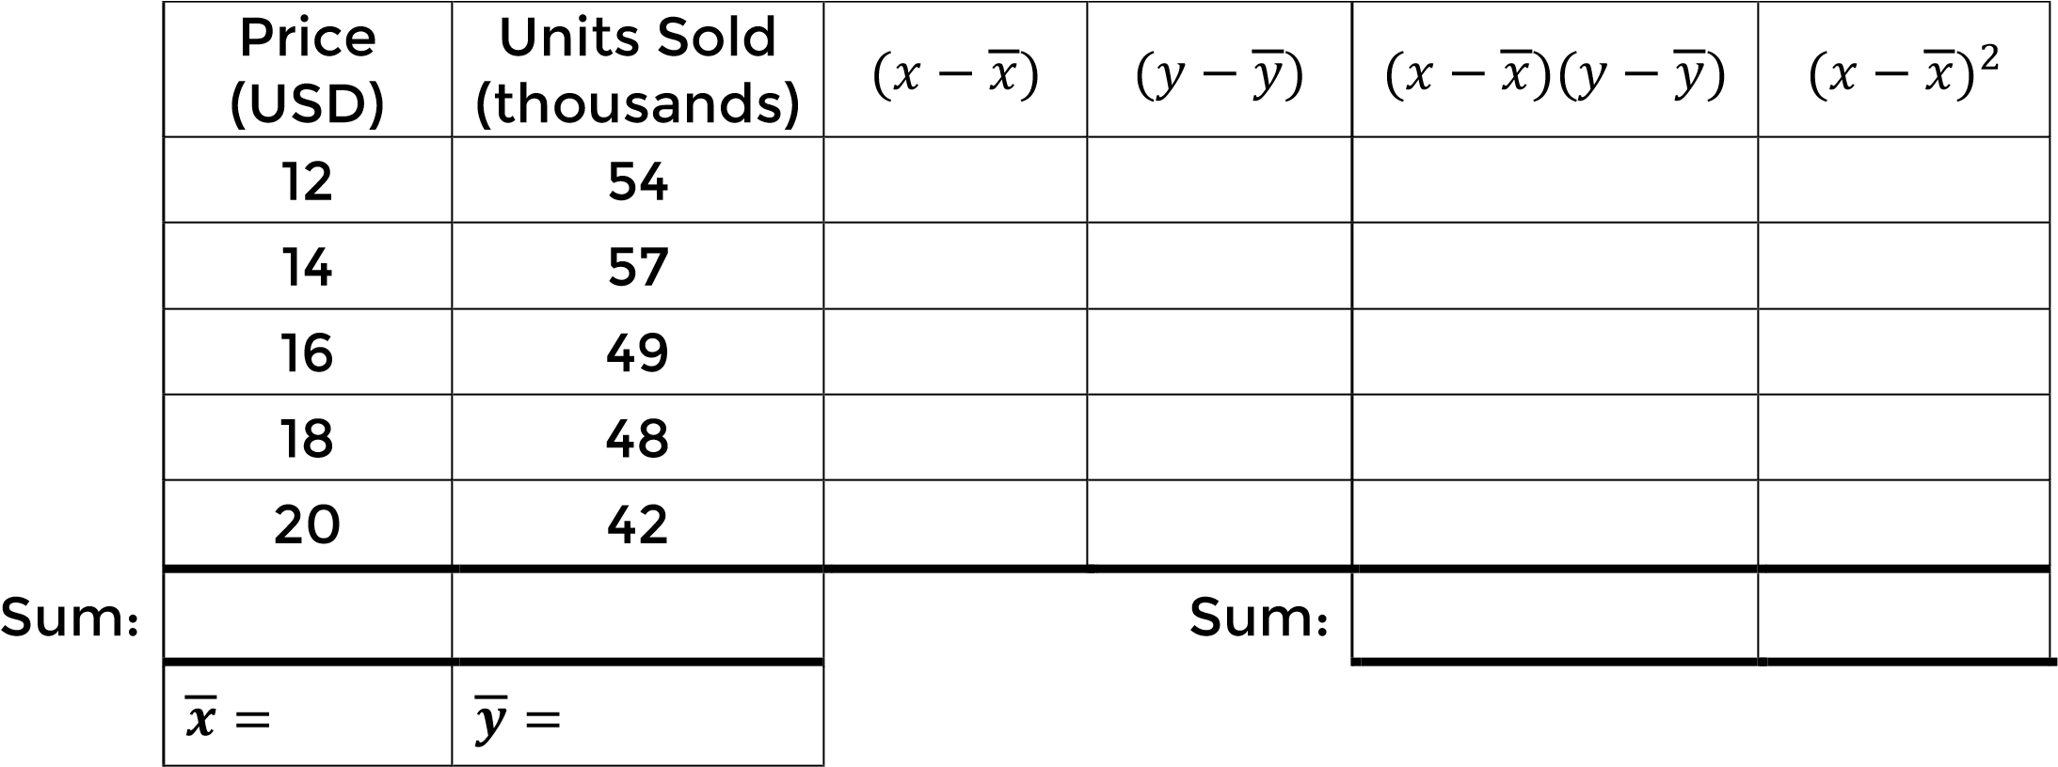

𝑏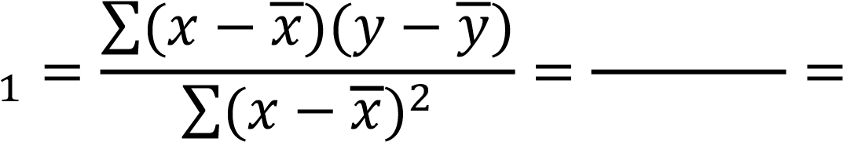

𝑏0 = 𝑦̅ − 𝑏1𝑥̅ = ( ) − ( )( ) =

# 𝑦̂ =

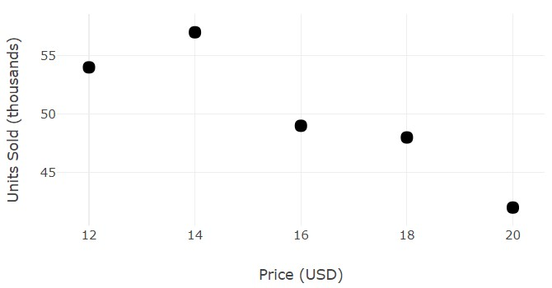

added image below:

